**CPT 203**

**Computer Graphics**

**Assessment 1**

**Xu Zhao**

**1927631**

**BSC Information and Computing Science**

**Introduction**

In this projection, a 2-dimensional Greeting Card for the 15th anniversary of XJTLU is created with the use of Mircrosoft Visual Studio VC++ and OpenGl environment. The Greeting Card is a square and the background is light blue. Characters ‘XJTLU 15th’ in an art font are on the top of the Greeting Card to represent the 15th anniversary of XJTLU. There are three trencher caps in the middle of the Greeting Card, which represent the university. In the bottom of the Greeting Card is a stick figure of 3-dimensional Centre Building of XJTLU. Centre Building is a key feature of XJTLU.

**Techniques**

In this design, a number of techniques covered in the module are used to make good visual effect.

1. Creation of geometry

All objects in the Greeting Card are combinations of geometries. Centre building is made up of 19 geometries, which is very complex. The colors of this objects are all obtained with Photoshop to be more real.

1. Transformations

You can transform the middle trencher cap of the three caps It can be moved to the left or right, rotated to the left or right. The scale of the trencher cap can also be changed

1. Viewing

Centre building in the Greeting is a 3-dimensional shape in 2-dimensional space. As a result, there is a feeling of viewing.

1. Animation

The characters ’15 th’ have the effect of animation, which can move in the horizontal direction.

1. Keyboard and mouse Interaction

The transformation and animation are associated with keyboard and mouse interaction. You can input character to control the movement, rotation and scale of the trencher cap. You can also play and pause the animation, change the direction of the movement of the characters or resume movement. Moreover, you can use mouse to change the speed of the animation.

**Instruction**

**Q** or **q**: exit program

Transformation of the trencher cap:

**A** or **a**: move to the left

**D** or **d**: move to the right

**Z** or **z**: rotate to the left

**C** or **c**: rotate to the right

**W** or **w**: become larger

**S** or **s**: become smaller

Animation:

**E** or **e**: change the direction of movement

**F** or **f**: stop movement

**R** or **r**: reset step(resume movement)

**The left mouse button**: obtain speed to left

**The right mouse button**: obtain speed to right

**Typical Screenshots**

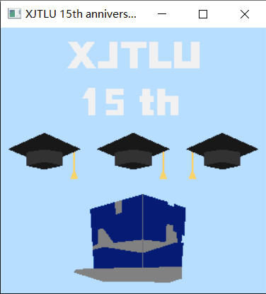

The original figure

2.

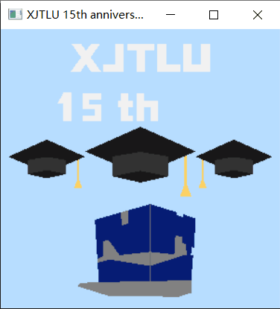

In this figure, the trencher cap is turned larger

3.

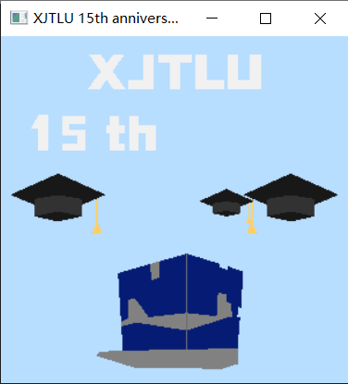

In this figure, the trencher cap is moved to the right and turned smaller.

4.

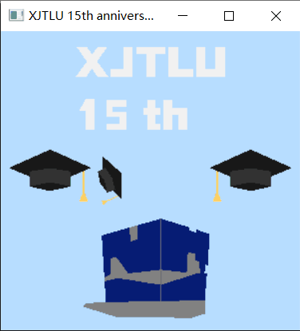

In this figure, the trencher cap is moved to the left, turned smaller and left rotated.